**Module 2 Assignment: JavaScript language**

Sushmita Prafull Halasawade

IFT 544: Middleware Prog & Database Sec

Dinesh Sthapit

3 Sep 2023

**JavaScript introduction 1:**

**JavaScript Function refactoring 2 :**

**JavaScript Refactoring 3:**

**JavaScript variables 4:**

**JavaScript Objects 5:**

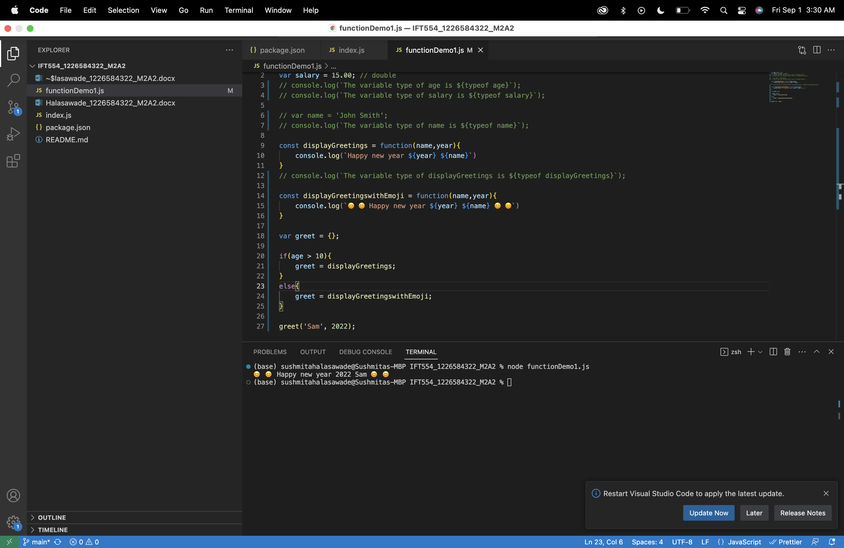

**JavaScript Parameter (Function as a parameter) 6:**

**JavaScript Master Document Reference (required) 7:**

**JavaScript Objects 8:**

**JavaScript Arrays 9:**

**JavaScript Accessing Elements of JavaScript Object Arrays 10:**

